DAY-3 S3 (Simple Storage Service)
Amazon S3 (Simple Storage Service)
- Amazon S3 (Simple Storage Service) is a scalable object storage service provided by AWS.
- S3 is a storage-based service used to store and retrieve data over the internet.
- Amazon S3 supports virtually unlimited storage capacity.
- Using S3, we can store any amount of data from anywhere at any time.
- S3 provides object-based storage, where data is stored as objects (files).
- Objects can be uploaded to and downloaded from S3 at any point in time.
- To store data in S3, we must create a bucket.
- A bucket is a logical container used to store objects in S3.
- Each bucket must have a globally unique name across all AWS accounts.
- Bucket naming rules:
  - Bucket names must be between 3 and 63 characters
  - Names must begin and end with a letter or number
  - Allowed characters: lowercase letters (a–z), numbers (0–9), periods (.), and hyphens (-)
- When a bucket is created, a bucket endpoint URL is generated.
- The bucket endpoint URL can be used to access the bucket.
- Each object uploaded to a bucket is assigned a unique object URL.
- By default, all S3 buckets and objects are private.
- Buckets and objects can be configured to allow public access, if required.
- An AWS account can create multiple buckets in Amazon S3.
- Amazon S3 follows a pay-as-you-go pricing model.
- S3 is a paid service, and charges depend on usage.
- Pricing is influenced by factors such as storage location (region), storage class, and data transfer.
- Creating a bucket in Amazon S3 is free, but storing and accessing data incurs charges.
- Amazon S3 offers multiple storage classes.
- Storage classes define how frequently objects are accessed and their cost.
- By default, objects uploaded to S3 use the Standard storage class.

Task-1
Creating a S3 Bucket
-Open AWS console and search S3 in dashboard and open S3.
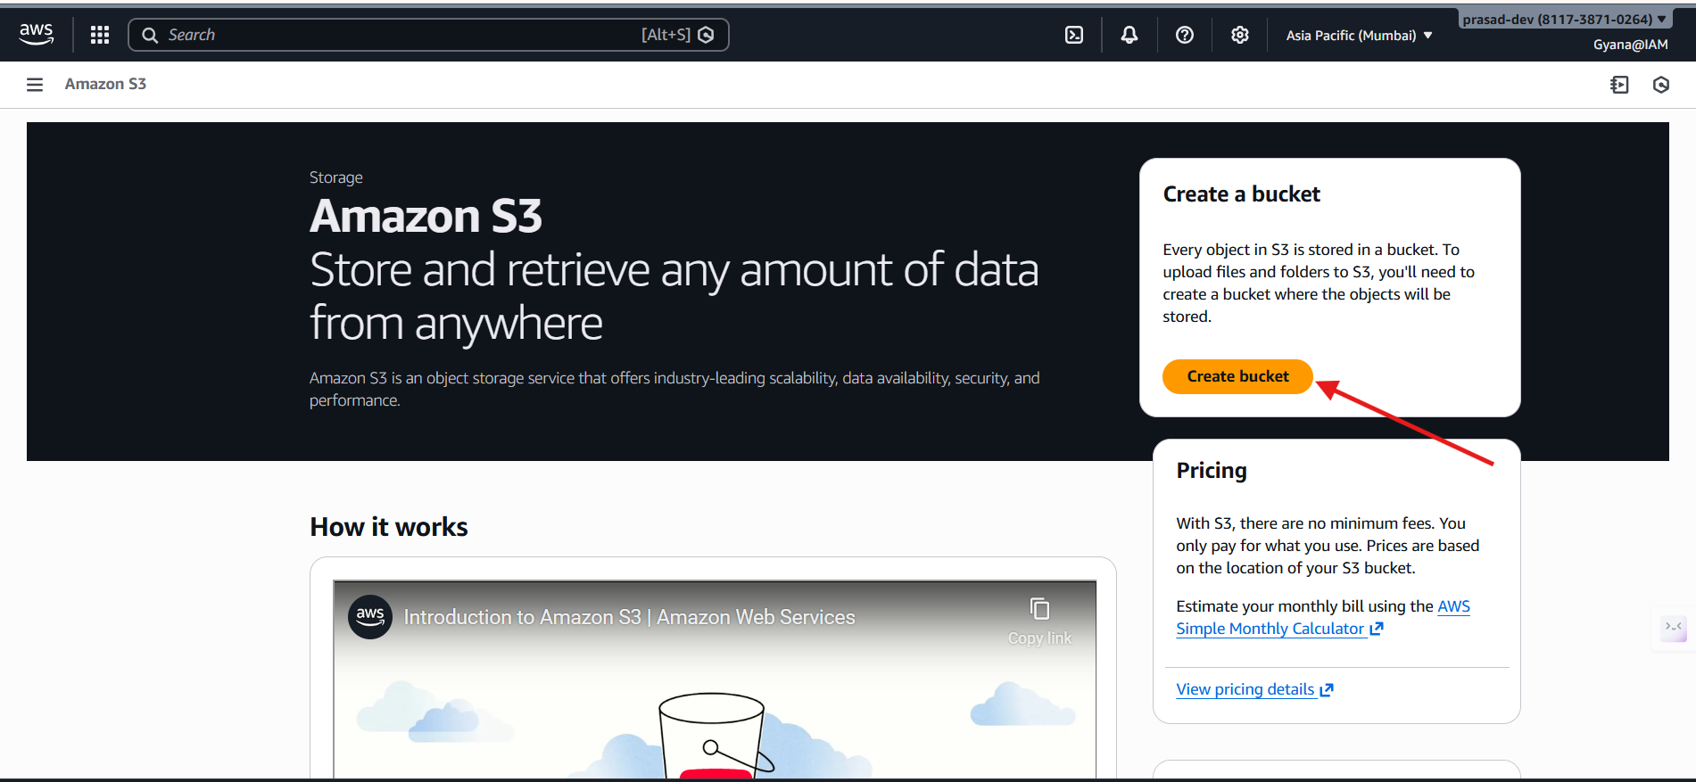
- Click on Create bucket
- A console will be open like this below image.
- Give the unique bucket name.
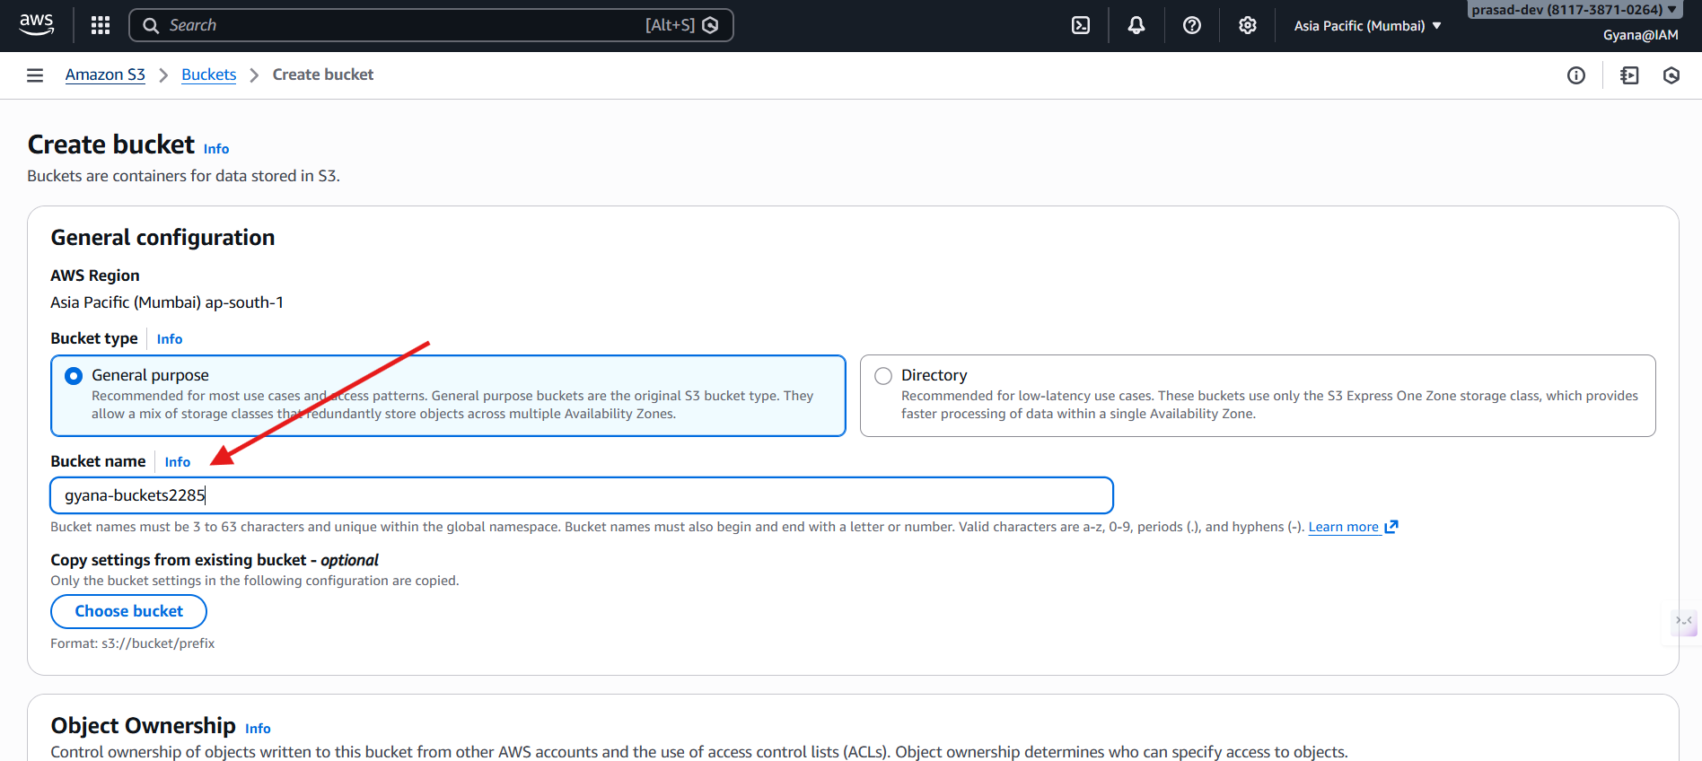
- Scroll it down and click create bucket.
- We can make so many changes to create buckets.
- In Object Ownership section we can enable and disabled ACLs and can uncheck the Block Public option to make the object private to public.
- Because by default the objects are private.
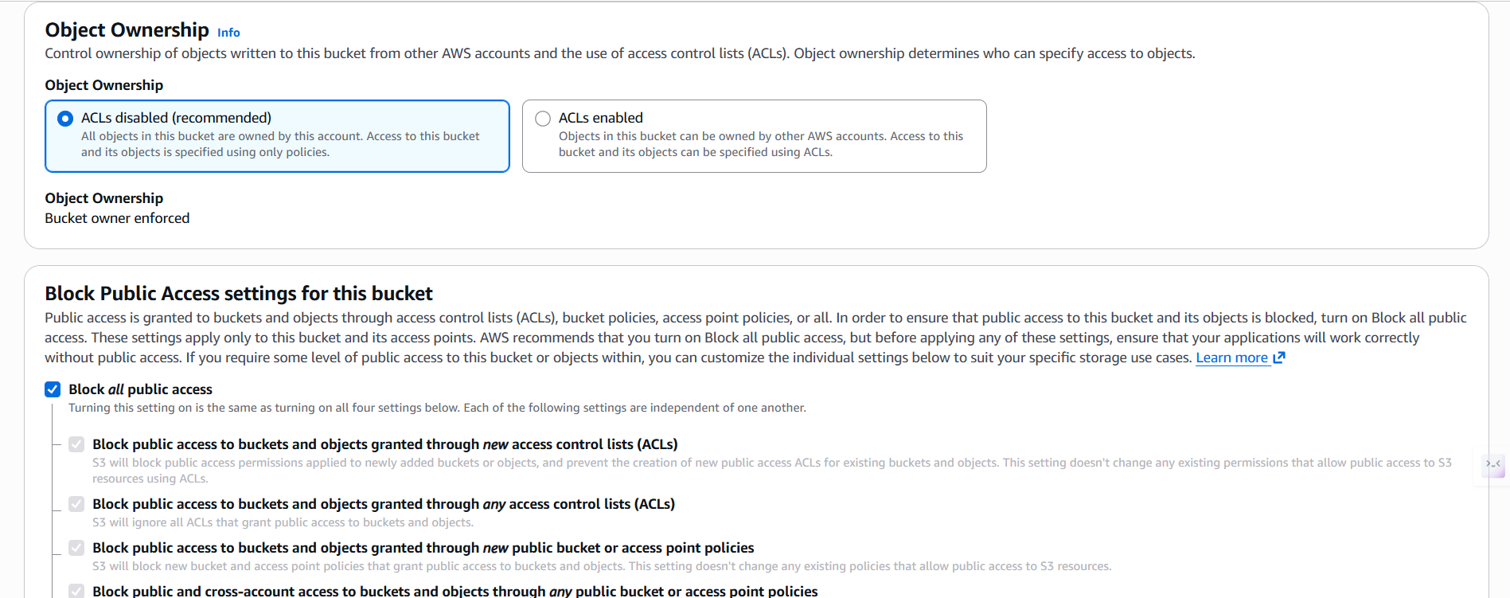
e) Now can create a bucket enabling and disabling the options to out requirement.
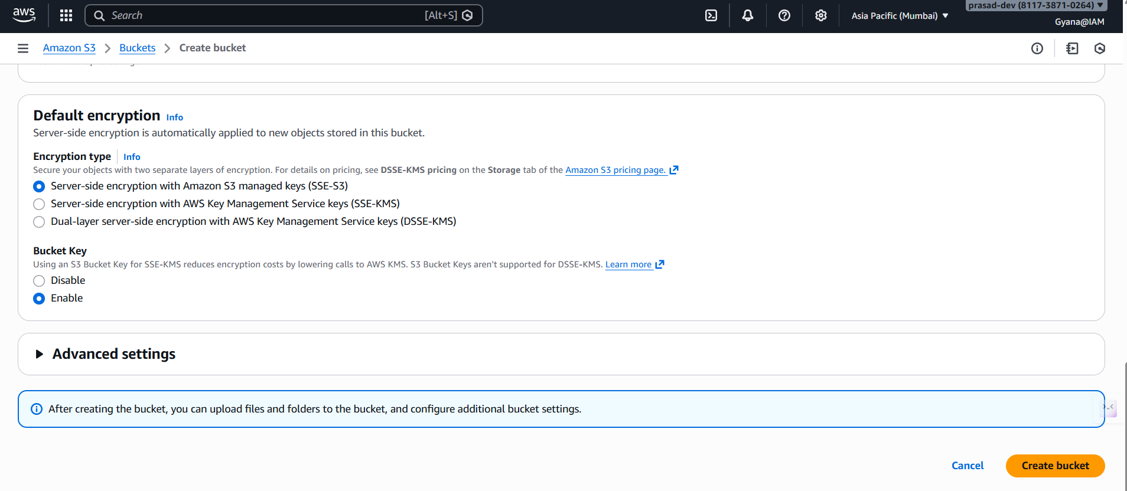
f) Bucket has been created.
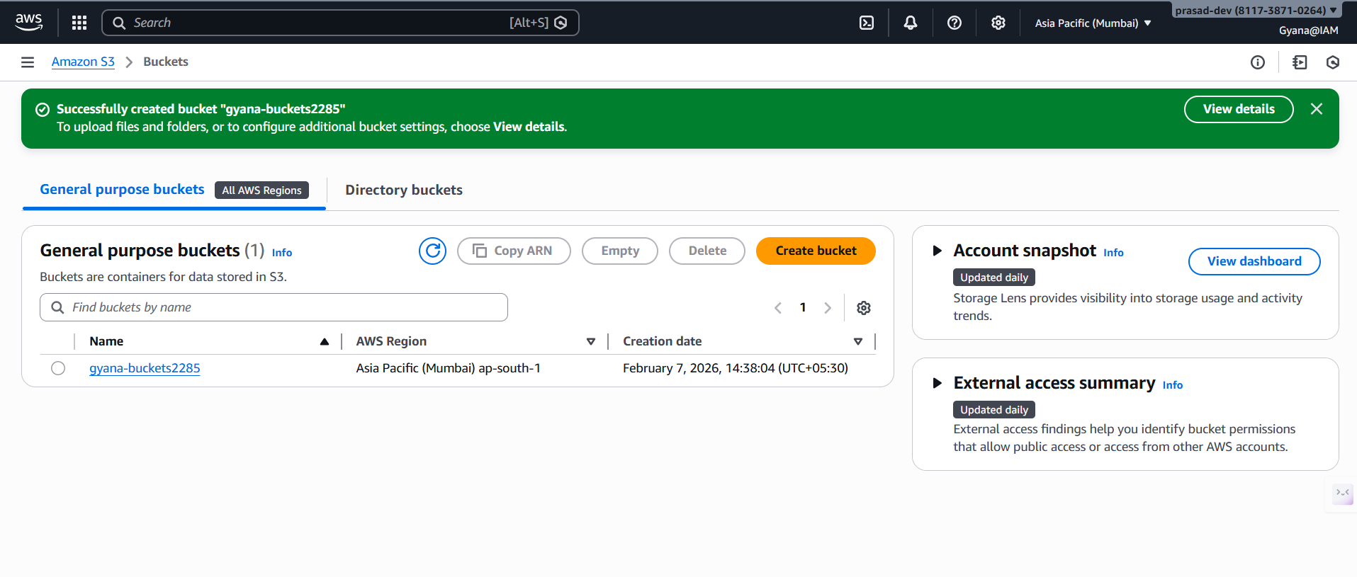
Delete the buckets after use.(Only for the practice purpose otherwise it will be charged)
Now click the delete button to delete the bucket.
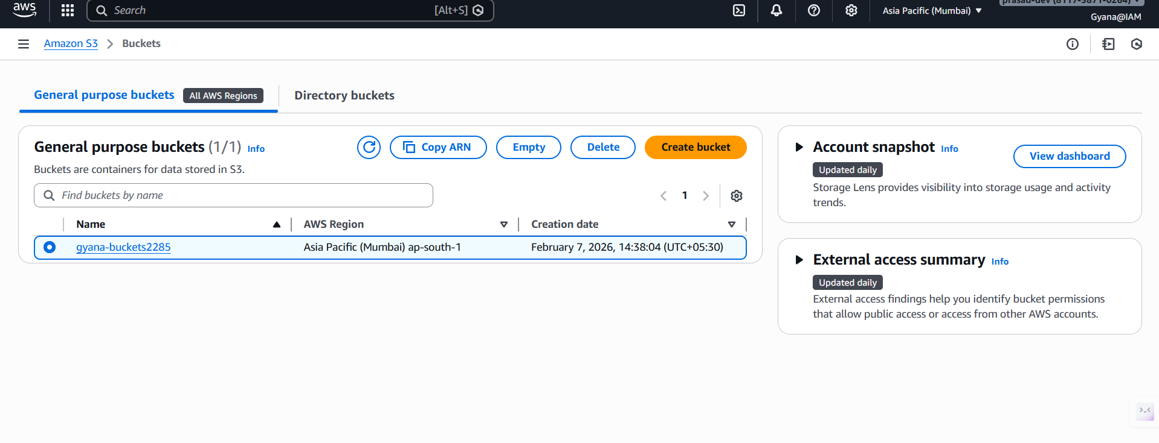
-Paste the bucket name and then hit Delete Bucket.
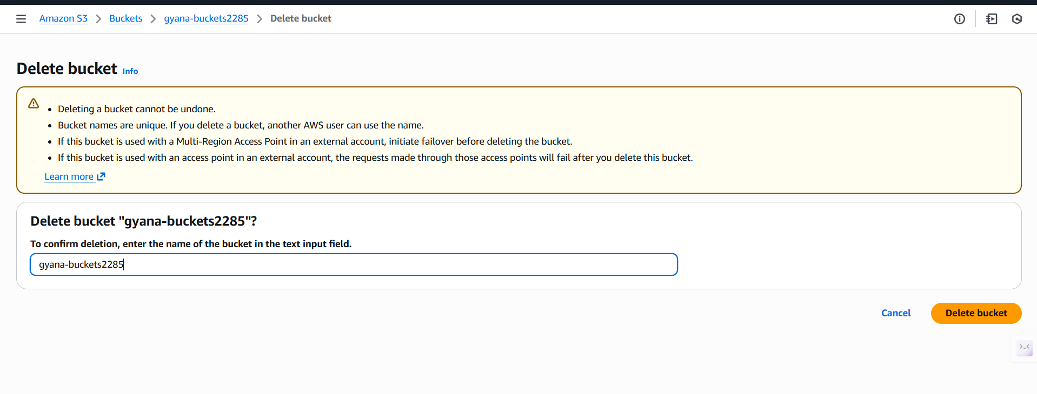
Successfully deleted the bucket.
